**Salesforce Project Implementation Phases**

**Phase 9**: **Reporting, Dashboards & Security Review**

This phase ensures that our **Telemedicine CRM** delivers actionable insights through reports and dashboards, while also maintaining enterprise-grade security through Salesforce’s built-in controls.

* **Reports (Tabular, Summary, Matrix, Joined**

Reports are used to analyze data such as patient appointments, prescriptions, or doctor workload.

**Types**

**- Tabular** → Simple list of records (e.g., all appointments today).

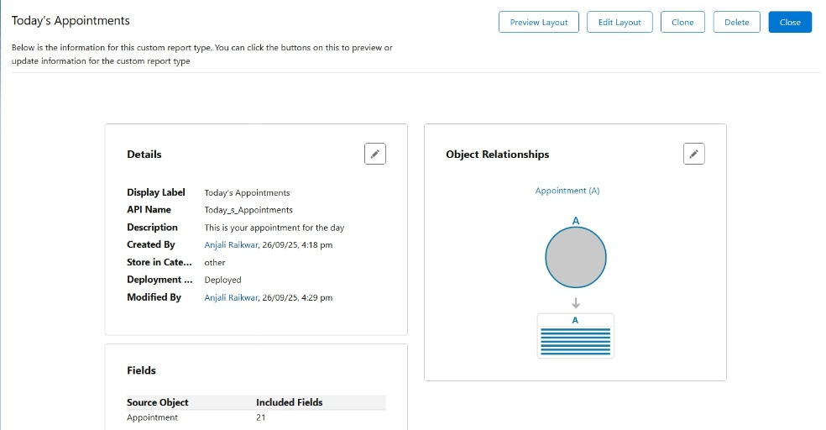

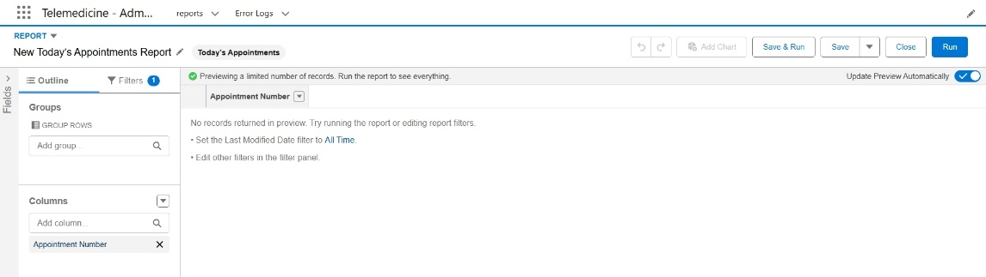

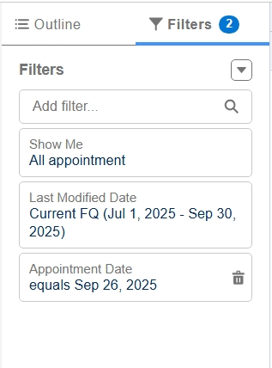

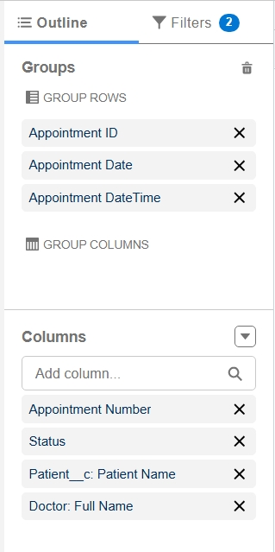

**- Summary** → Grouped by a field (e.g., appointments grouped by doctor).

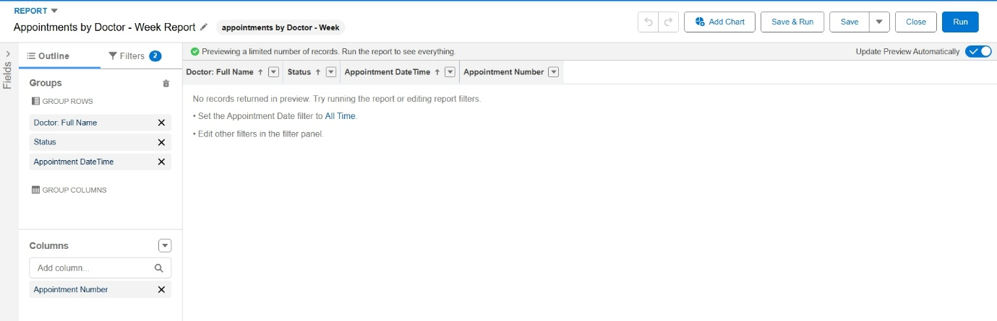

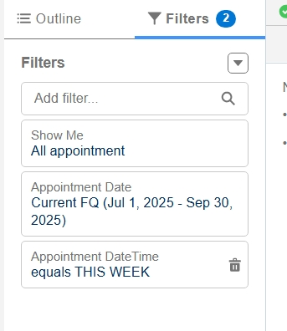

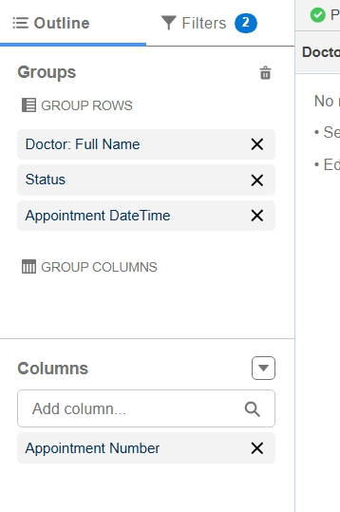

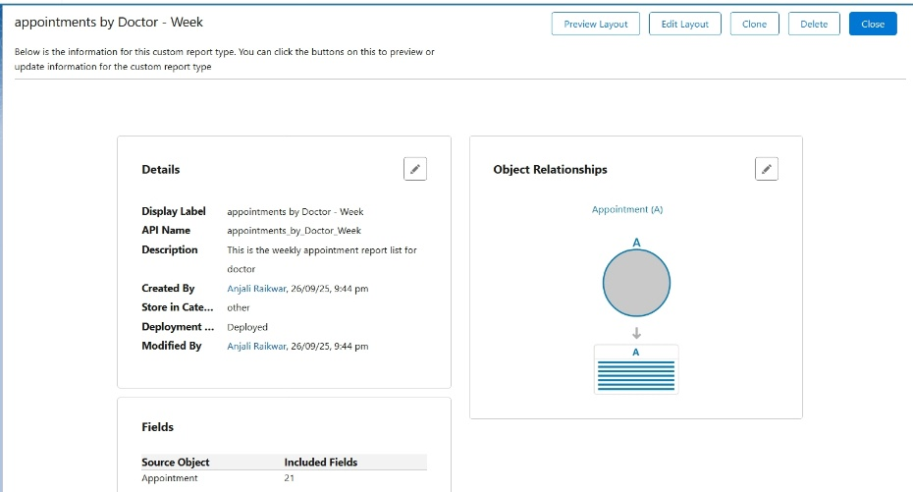

**-** **Matrix** → Grouped both rows & columns (e.g., doctors vs. appointment status).

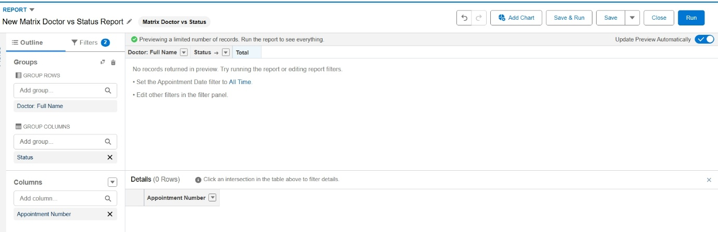

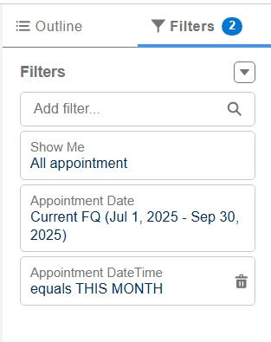

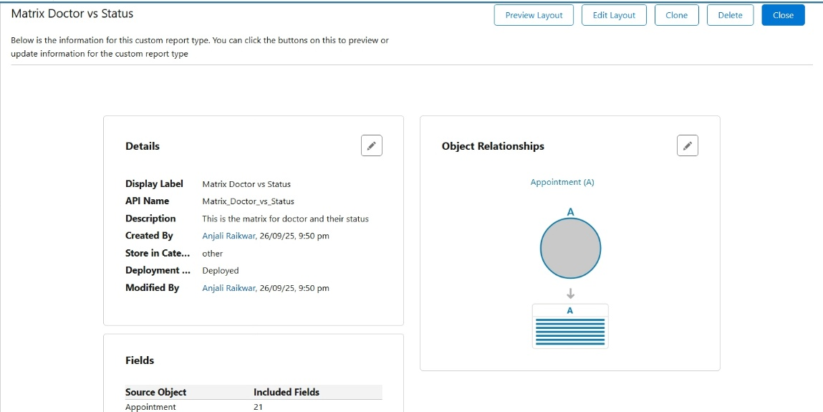

**- Joined** → Combine multiple report types ( patient records + prescription data).

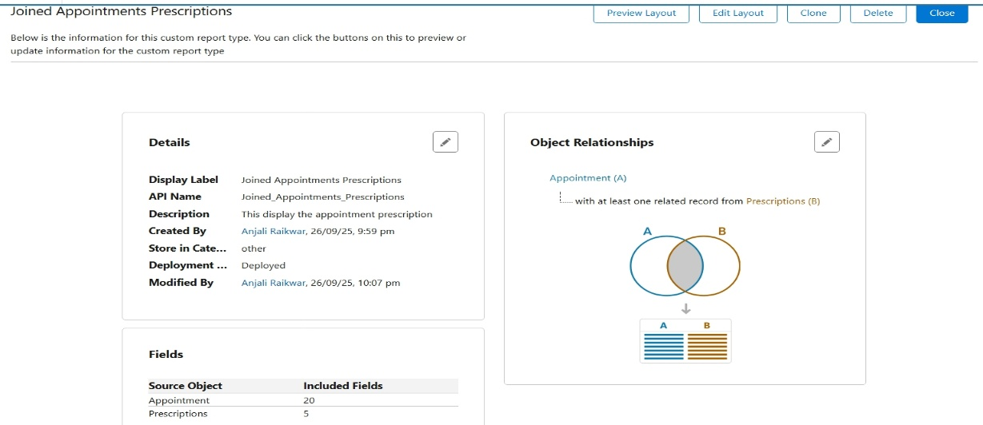

**Best Use Case** → Monitor doctor performance, patient volume, and prescription trends.

* **Report Types**

Define which objects and fields are available in reports.

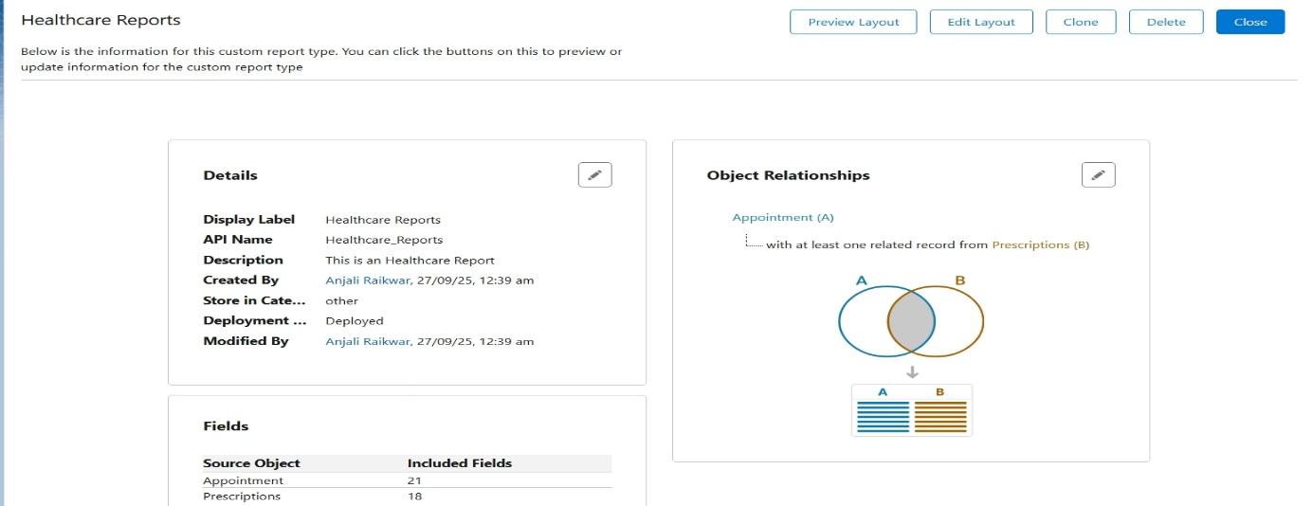

**Best Use Case** → Custom objects reporting (Appointments + Prescriptions).

* **Dashboards**

Visualize multiple reports in one view (graphs, charts, gauges).

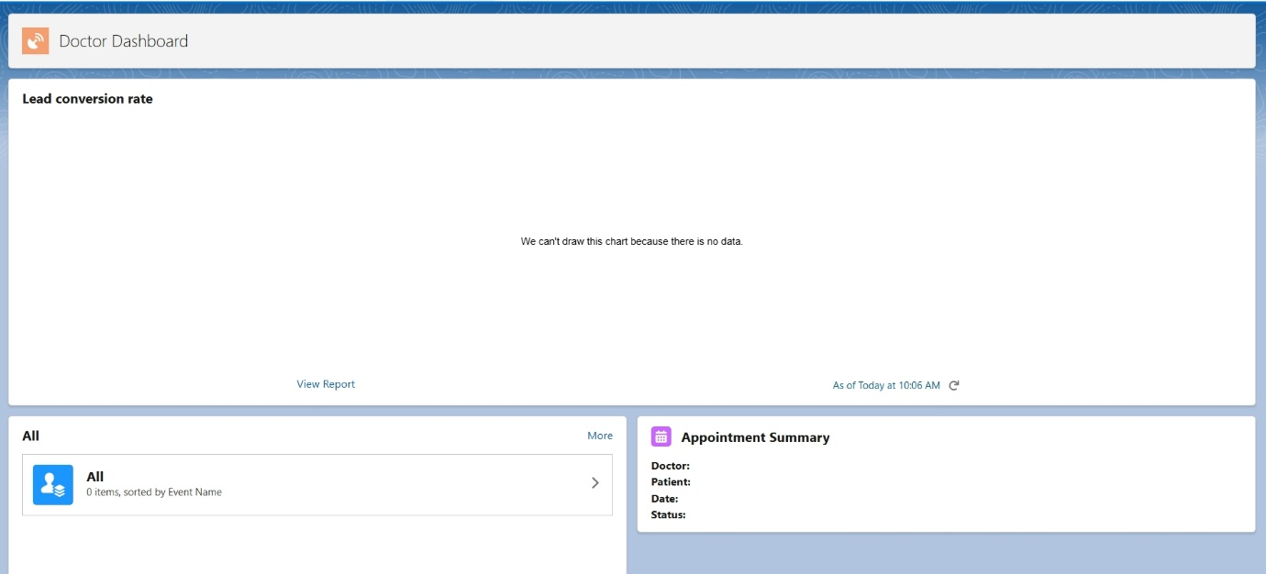

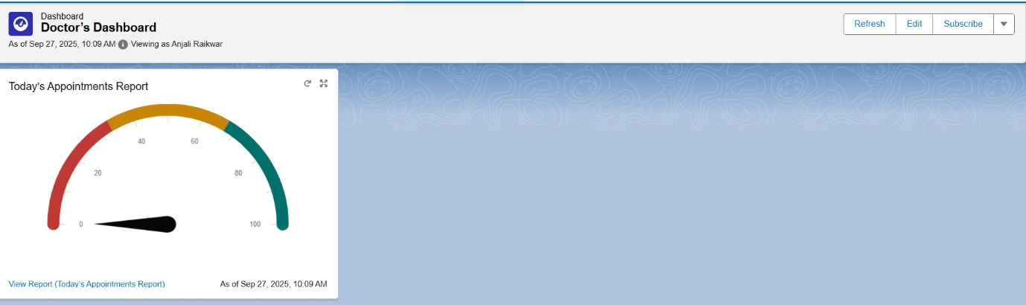

**Best Use Case** → Doctor’s dashboard:

**-** Todays Appointments (list)

**-** Appointment Status (pie chart)

**-** Top 5 Patients (bar chart)

* **Dynamic Dashboards**

Dashboards that run as the logged-in user → each doctor sees their own data without creating multiple dashboards.

**Best Use Case** → Each doctor automatically sees only their patients/appointments.

* **Sharing Settings**

Controls record-level access (private vs public data).

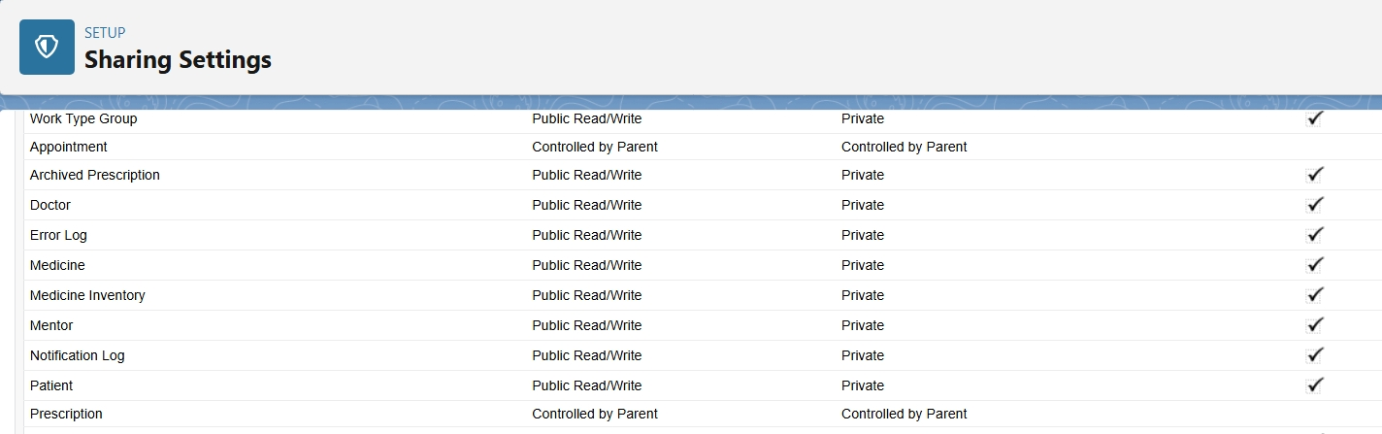

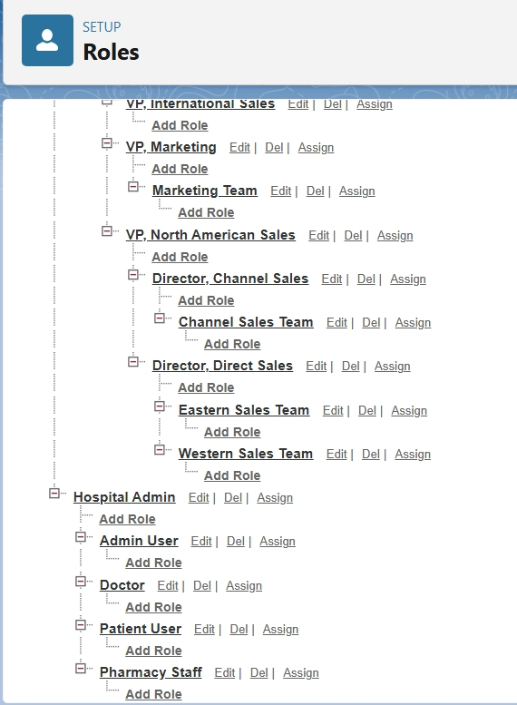

**Best Use Case** → Protect patient confidentiality.

* **Field Level Security**

Hide sensitive fields (e.g., Patient Medical History) from unauthorized users.

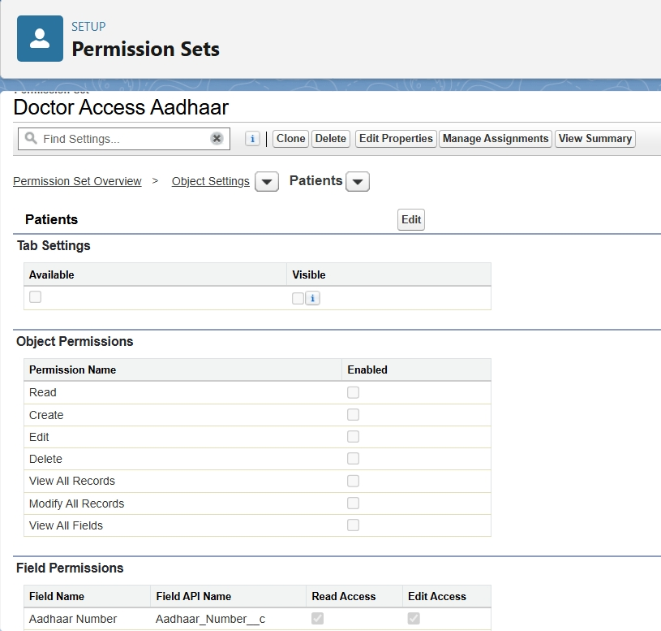

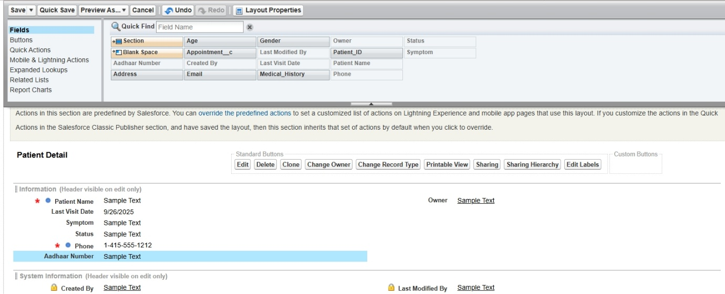

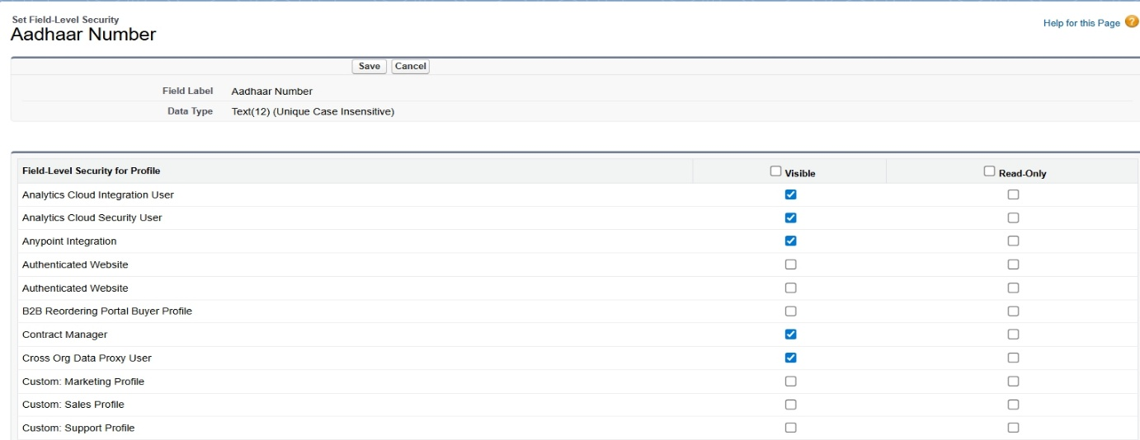

**Best Use Case** → Admin sees everything, Receptionist only sees Appointment Time & Patient Name.

* **Session Settings**

Controls login security (timeouts, session restrictions).

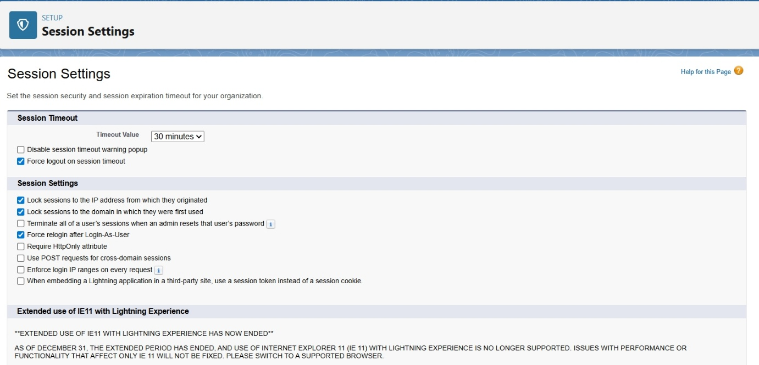

**Best Use Case** → Auto log out idle users to prevent unauthorized access.

* **Login IP Ranges**

Restrict user logins to trusted networks (e.g., hospital Wi-Fi).

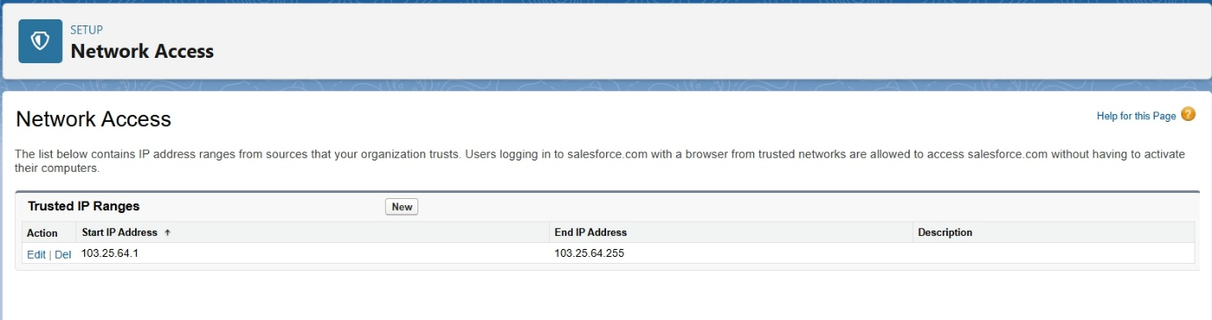



**Best Use Case** → Prevent external logins outside hospital network.

* **Audit Trail**

Track who changed what in setup for compliance.

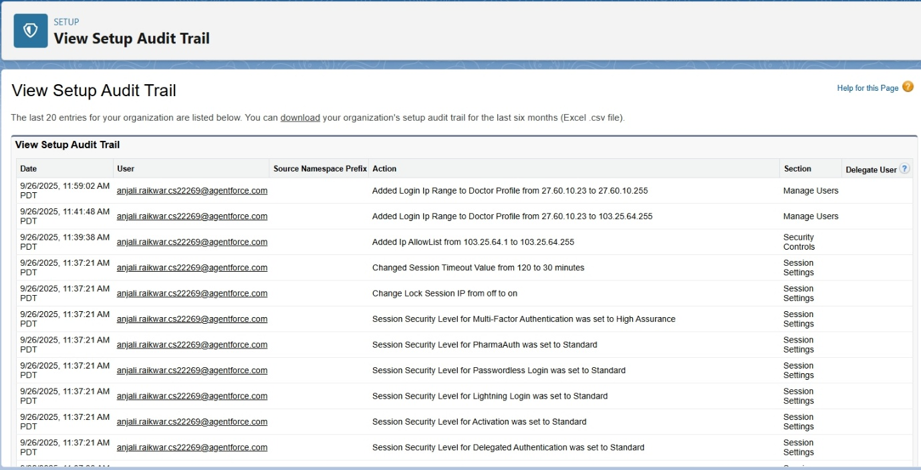

**Best Use Case** → Security reviews, compliance with healthcare regulations (HIPAA/GDPR).